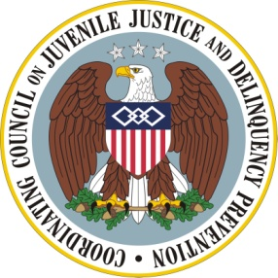

The Agenda

Coordinating Council on Juvenile Justice and Delinquency Prevention
Quarterly Meeting

Tuesday, November 18, 2014

U.S. Department of Justice, Office of Justice Programs
810 Seventh Street, NW, 3rd Floor Conference Center, Washington, DC 20531

10:30-10:40 am Ceremonial Opening

Eugenia Tyner-Dawson (Sac and Fox Nation), Senior Advisor to the OJP AAG for Tribal Affairs and Executive Director for the Justice Programs Council on Native American Affairs

Clayton Old Elk (Apsaalooke' Nation - Crow Nation)

Joanne Shenandoah (Iroquois), Co-Chair, Attorney General’s Advisory Committee on American Indian and Alaska Native Children Exposed to Violence

10:40-11:00 am Opening Remarks

Kathi L. Grasso, Designated Federal Official, Coordinating Council, Office of Juvenile Justice and Delinquency Prevention (OJJDP), U.S. Department of Justice

Mary Lou Leary, Principal Deputy Assistant Attorney General, Office of Justice Programs (OJP), U.S. Department of Justice

Stuart F. Delery, Acting Associate Attorney General, U.S. Department of Justice

Robert L. Listenbee, Administrator, OJJDP, and Vice Chair, Coordinating Council, U.S. Department of Justice

Kevin K. Washburn, Assistant Secretary-Indian Affairs, U.S. Department of Interior

11:00-11:30 am Attorney General’s Advisory Committee on American Indian and Alaska Native Children Exposed to Violence: Report Presentation

Senator Byron L. Dorgan, Co-Chair, Advisory Committee

Anita Fineday (White Earth Band of Ojibwe), Advisory Committee

Valerie Davidson (Yup’ik) Advisory Committee

Joanne Shenandoah (Iroquois), Co-Chair, Advisory Committee

11:30 -11:55 am Council Member Discussion of Advisory Committee’s Presentation

11:55-12:00 pm Meeting Adjournment

Robert L. Listenbee, Administrator, OJJDP, Council Vice Chair

