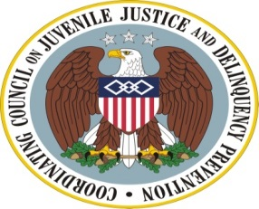
The Agenda

Coordinating Council on Juvenile Justice and Delinquency Prevention
Quarterly Meeting

Monday, July 28, 2014

U.S. Department of Justice, Office of Justice Programs
810 Seventh Street, NW, 3rd Floor Conference Center, Washington, DC 20531

10:00-10:15 am Welcome, Opening Remarks, and Introductions

Tony West, Associate Attorney General, U.S. Department of Justice (DOJ)

Karol Mason, Assistant Attorney General, Office of Justice Programs (OJP), U.S. Department of Justice (DOJ)

Roy Austin, Deputy Assistant to the President for Urban Affairs, Justice, and Opportunity, The White House

Robert Listenbee, Administrator, Office of Juvenile Justice and
Delinquency Prevention (OJJDP), DOJ, Vice Chair, Coordinating Council

10:15-11:50 am Setting a New Vision for Juvenile Reentry: Reducing Recidivism and Improving Other Youth Outcomes

Council Member and Invited Expert Discussion

Topics Addressed
- OJJDP Juvenile Reentry Strategic Plan
- Promoting efforts by states to track youth outcomes
- Research findings on what works to improve youth outcomes
- Assessing and reforming state policies and practices
- Federal efforts to reduce barriers to successful reentry for juveniles
- Evaluating the impact of diversion and reentry initiatives

11:50-11:55 am Council Member Announcements

11:55 am-12:00 pm Meeting Adjournment
Robert Listenbee, Administrator, OJJDP, Council Vice-Chair

