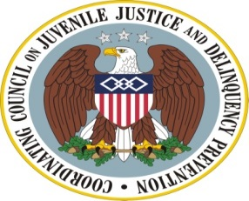

The Agenda

Coordinating Council on Juvenile Justice and Delinquency Prevention
Quarterly Meeting

Wednesday, April 9, 2014

U.S. Department of Justice, Office of Justice Programs
810 Seventh Street, NW, 3rd Floor Conference Center, Washington, DC 20531

11:00-11:15 am Welcome, Opening Remarks, and Introductions

Karol Mason, Assistant Attorney General, Office of Justice Programs (OJP), U.S. Department of Justice (DOJ)

Tony West, Associate Attorney General, DOJ

Robert Listenbee, Administrator, Office of Juvenile Justice and
Delinquency Prevention (OJJDP), DOJ, Vice Chair, Coordinating Council

11:15-11:55 am The Supportive School Discipline Initiative and Related Efforts

2011-12 Civil Rights Data Collection (15 minutes)
Catherine Lhamon, Assistant Secretary for Civil Rights, Office for Civil Rights, U.S. Department of Education (ED)

Marlyn Tillman, Co-chair, Gwinnett Parent Coalition to Dismantle the School to Prison Pipeline (Gwinnett SToPP) & School to Prison Pipeline Director, American Civil Liberties Union of Georgia (ACLU-GA)

Discipline Disparities Research to Practice Collaborative (15 minutes)
Russell Skiba, Director, Discipline Disparities Research to Practice Collaborative, the Equity Project, Indiana University

James Bell, Founder and Executive Director, W. Haywood Burns Institute

National Council of Juvenile and Family Court Judges
School Pathways Project (10 minutes)
Chandlee Johnson Kuhn, Chief Judge, Family Court of the State of Delaware

11:55 am-12:25 pm Council Member Discussion

12:25-12:35 pm Agency and Practitioner Announcements

12:35 pm Meeting Adjournment
Robert Listenbee, Administrator, OJJDP, Council Vice Chair

