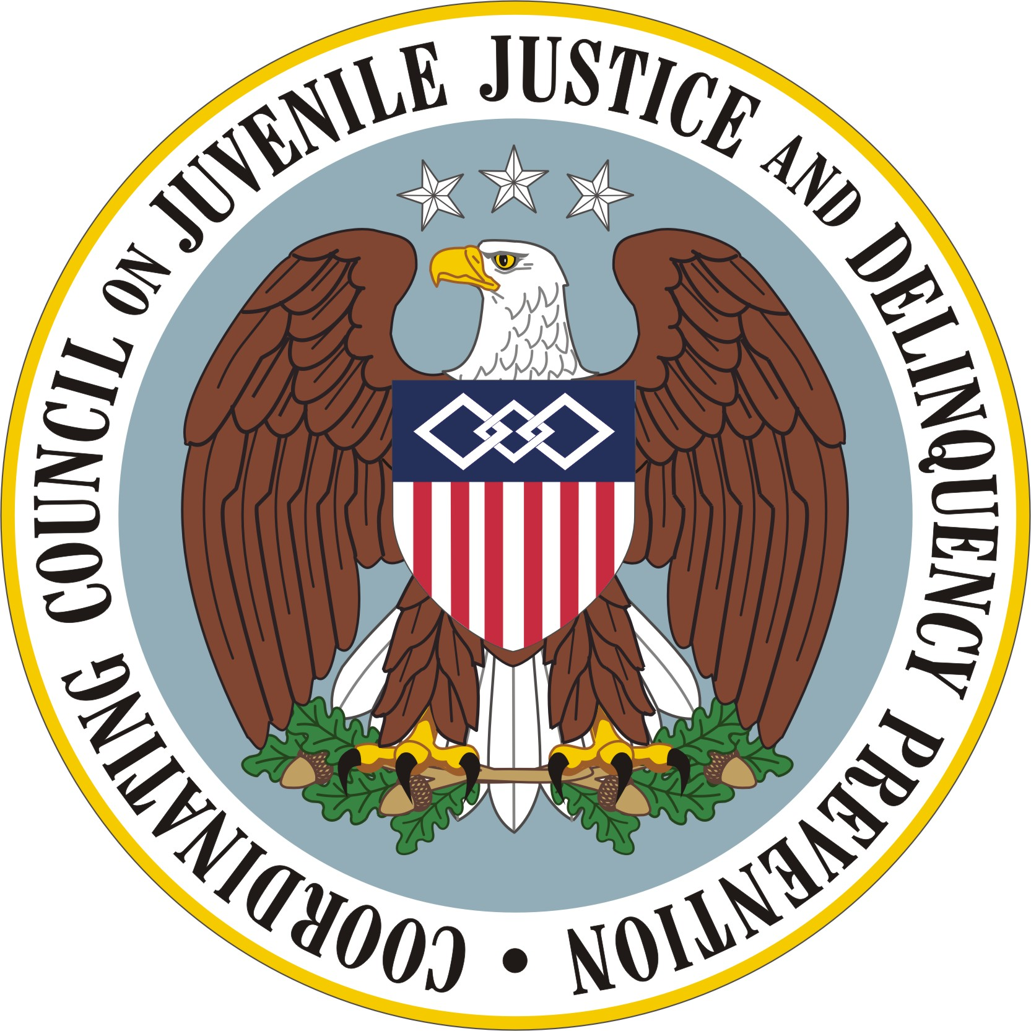

Coordinating Council on Juvenile Justice
and Delinquency Prevention

Quarterly Meeting

January 25, 2010

U.S. Department of Justice, Office of Justice Programs
810 Seventh Street NW, 3rd Floor, Washington, DC 20531

3:15–3:25 p.m. Welcome, Introductions, Call to Action
The Honorable Eric H. Holder, Jr., Attorney General, Coordinating Council Chair

3:25–3:35 p.m. Report on Recommendations of the Executive/Operations Committees
Vice Chair Jeff Slowikowski, Acting Administrator,
Office of Juvenile Justice and Delinquency Prevention

3:35–3:50 p.m. Observations from Practitioners and Discussion
Mr. Slowikowski

3:50–3:55 p.m. Call for Motion, Ratification of Committee Recommendations
General Holder

3:55–4 p.m. Next Steps, Adjournment
General Holder

